Guidance for ARCH students using Microsoft Teams
This guidance describes the steps to be taken to join a group session using Microsoft Teams, and some ground rules to ensure the sessions are safe for everyone.
Your name will be visible to everyone on the session as you type it when you join the session. You might wish to type your first name only, and do not use your email address.
How to join a group session
- Open the email you will have received from a TEWV NHSMail address.
- In the body of the email will contain a link that looks like this:
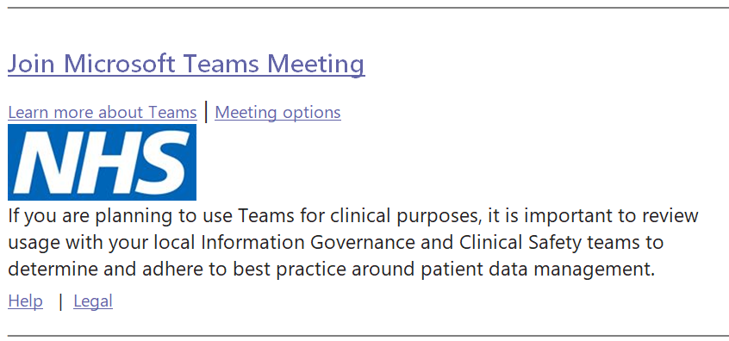

- Select the ‘Join Microsoft Teams Meeting’ link

At this point, if you don’t already have MS Teams on your device, depending on the device you are using one of the following screens will appear:

Screen One:
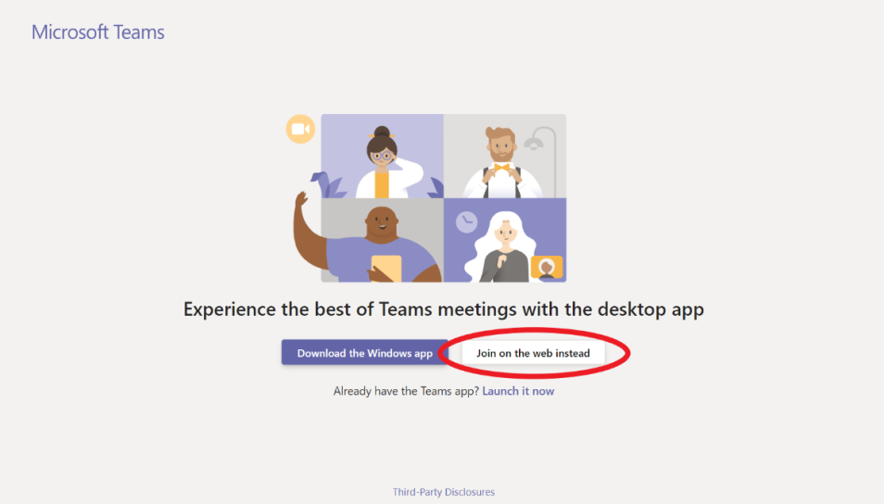
Note: Some browsers are not capable of joining a Teams meeting. Please use either Microsoft Edge or Google Chrome for the full experience. Additionally, you can "Download the Windows app" or Mac app if you do not have Edge or Chrome.

Screen Two:
Download the app from Google Play or App Store

- Once you have downloaded either of the above the below screen will appear – ensure you click ‘Join as a guest.’

When prompted, click Allow to allow Teams to record audio – you need to do this so that the video and audio conferencing works for you.

Ground Rules

Important: How you type your name will be visible to everyone on the session. You may wish to just use your first name. Don’t use your email address.
To protect the confidentiality of others, recording of any part of the session is not permitted by anyone.
There is a messaging function on Teams and you may wish to share some of your thoughts during the session. Remember that everyone will be able to see what you write – no swearing please!
Just like classes at ARCH, if we are worried about something someone says or writes, we will speak to them about it, and if necessary, contact their emergency contact or care team.
If you have any worries about any other participant, you can email us to let us know.
The music sessions have an evaluation form – please do fill this in if you can as we want to make these available for lots more people and can only do so if we have feedback.

Any questions? Email us at tewv.recoverycollege@nhs.net

