How to support people with dementia to hand wash (during the COVID-19 pandemic)
- Whilst handwashing is crucial to reducing the spread of COVID-19, it is something that a person living with dementia may struggle to do. This may be due to cognitive impairment and/or sensory difficulties.
- People living with dementia can experience aversion to the smells, images, sounds and the tactile sensations of hand washing. They may also have problems with balance, muscle tone or co-ordinating their hand movements, not understand the step-by-step process of hand washing, or simply lose concentration and forget what they were doing.
- The following suggestions should be tailored to the specific strengths and difficulties of the person living with dementia whom you are supporting to hand wash;
  - Explain the process of hand washing using the World Health Organisation’s (WHO) step-by-step hand washing guide if needed:
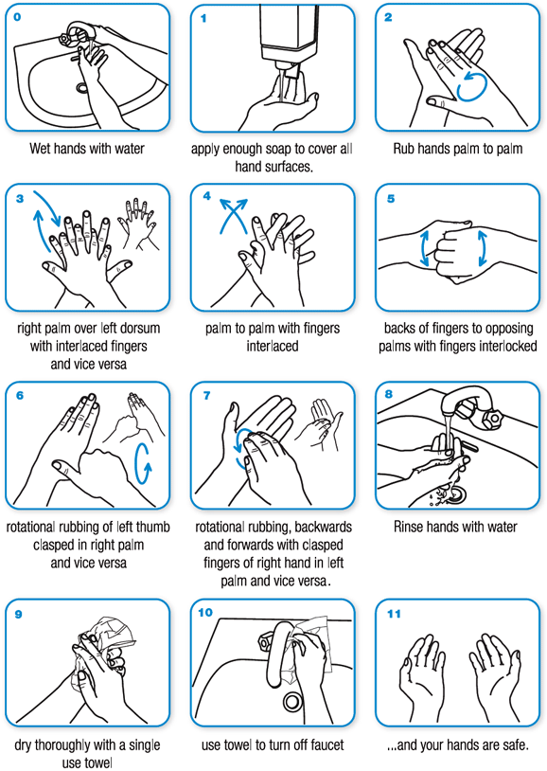

Here is the link should you wish to print: https://www.who.int/gpsc/clean_hands_protection/en/

  - Prompt hand washing at appropriate times, either verbally, by gesture (miming turning a tap or rubbing one’s hands together), or using a handwashing image or poster. If required you may need to physically help the person living with dementia to wash their hands. Remember to promptly give praise and acknowledgement each time they wash their hands.

  - Tackling sensory issues - If you know that the person living with dementia has a preference for liquid soap or solid soap bars ensure that the correct one, and ideally the preferred/usual brand, is to hand. Also find out if they favour a particular smell, or if they prefer unscented soap. If they dislike the sensation of touching soap, consider placing the soap in a fabric pouch, so they only have to touch the suds.

  - Water Temperature. Assessing a safe water temperature may be difficult for the person living with dementia, and they may need assistance. Some people living with dementia may find slightly warm water more tolerable than cold water.

  - Antibacterial Hand Gel - If soap and water are really not an option or not available, then use antibacterial hand gel. You may need to demonstrate how to use this and assist. Again, you may need to investigate whether scented or unscented ones, gel or spray ones are preferred.

  - Hand Lotion - Some people living with dementia are distracted by the tactile sensation after they have washed their hands. Investigate if this is eased by using a preferred hand lotion immediately afterwards. Repeated hand washing can also dry out the hands, so consider using hand lotion regularly after hand washing.

- Supporting someone living with dementia to effectively hand wash will be particularly important if they are unable to refrain from touching their face.

- In discussing the difficulty of getting someone living with dementia not to touch their face, Teepa Snow (Dementia Care Expert) states: “It’s not going to happen, so we’ve got to let go of that one. The face is a highly sensitive part of the human body, the hands are highly sensitive parts of the human body, and the more that someone is anxious or nervous from losing contact with other human beings, what else are they supposed to do with their hands? Touching the face is one of the very first things babies ever do in the world, and we’re saying now that we’ve got to get them to not do that? That’s not going to happen. The idea that we can regulate behavior of someone who is [living with dementia], to not do a habitual behavior that is based on a sensory need, is illogical.” Here is a link to the ‘being patient’ interview with Teepa Snow: https://www.beingpatient.com/covid-19-dementia-caregiver-steps/

