How to maintain your wellbeing as a carer (during the COVID-19 pandemic)

Whilst the present COVID-19 pandemic is impacting upon how we all live our lives currently, for those with additional care responsibilities – for example those caring for someone living with dementia - this is perhaps felt more acutely.

Looking after your own wellbeing is extremely important – even at the best of times. However, at this present time, it is perhaps particularly important that you make the time to identify and attend to your own wellbeing needs, make the time to stay connected to others, and remain physically and mentally stimulated. This document intends to provide some links to key websites, each with specific resources to help maintain your wellbeing during the COVID-19 pandemic (and beyond!).

Specialist Advice & Support
The ‘Alzheimer’s Society’ website highlights the additional challenges faced by those caring for someone with dementia in the face of the COVID-19 pandemic. They provide information for people affected by dementia, advice on supporting a person with dementia at home, activity ideas for people living with dementia, support for a person living alone or at a distance, and answers to other frequently asked questions. Here is a link to the website: https://www.alzheimers.org.uk/get-support/coronavirus-covid-19

Maintaining your Mental Wellbeing
The charity ‘Mind’ have published some guidance titled ‘Coronavirus and your Wellbeing’, which can be found on their website: https://www.mind.org.uk/information-support/coronavirus/coronavirus-and-your-wellbeing/
‘mentalhealth.org.uk’ have produced the following ‘sketchnote’ highlighting all the things you can do to look after your mental health during the COVID-19 pandemic:

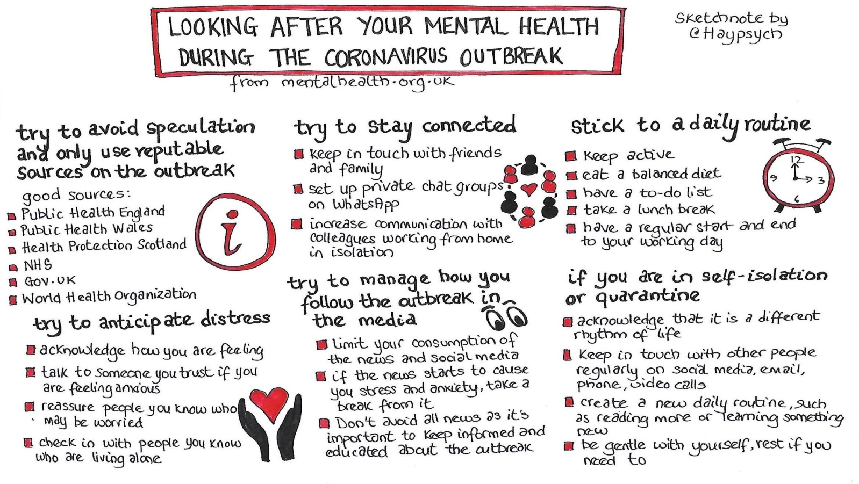

‘Self-soothing’ techniques may be beneficial if you feel that your wellbeing has been compromised. Below are some strategies that you may want to try;

‘Grounding’
Grounding is a technique that helps keep someone in the present, or helps re-orient a person to the present. Grounding techniques can be helpful in managing overwhelming feelings or intense anxiety. They can help someone to regain their mental focus from an often intensely emotional state. Here are some grounding techniques you may want to try;

- Count backwards from 10
- Name 5 things you can see in the room with you, name 4 things you can feel (e.g. “chair on my back” or “feet on floor”), name 3 things you can hear right now, name 2 things you can smell right now (or 2 things you like the smell of), and finally name 1 thing you can taste.
- Name as many breeds of dog/car makes etc. as you can (category technique).
- “How many things in the room are the colour red/yellow/green/blue?”
- Put hand cream on/smelly shower gel or perfume.
- Physically grounding yourself – place both feet on the floor, feel your weight on the seat, touching the seat, say the date, year, name etc.
- Carry a grounding object with you. Some people carry a stone or other small object, which perhaps has personal meaning, to comfort and touch when they need to.

‘Distraction’
This is purely about temporarily distracting you from whatever is impacting on your wellbeing presently:
- Try to appreciate any small details in your surroundings.
- Focus on your breathing, for example, how it feels to breathe in and out
- Listen to your favourite music. Try to pick out all the different instruments and sounds that you can hear
- Engage with an activity that you know you enjoy/brings pleasure to you.

‘Mindfulness’
Mindfulness is a mental state achieved by focusing one’s awareness on the present moment, while acknowledging and accepting feelings, thoughts, and bodily sensations.

By being fully present in this way – not forcing things or hiding from them, but actually ‘being with’ them - we create space to respond in new ways to situations and make wise choices.

Here is a ‘three-minute breathing space’ you may wish to try: https://www.youtube.com/watch?v=rOne1P0TKL8

Alternatively, here is a longer (14 minute) ‘body scan’ you may wish to try:
https://www.youtube.com/watch?v=CyKhfUdOEgs

‘Other’
mentalhealth.org.uk’ have published a list of ideas for ‘Random acts of kindness during the Coronavirus outbreak’: https://www.mentalhealth.org.uk/coronavirus/random-acts-kindness
‘The Royal College of Occupational Therapists’ have produced some advice on ‘staying well when social distancing’. Here is a link to the website: https://www.rcot.co.uk/staying-well-when-social-distancing

The ‘Campaign to End Loneliness’ has some useful guidance on how people can combat loneliness when in social isolation. Here is a link to their website: https://www.campaigntoendloneliness.org/blog/coronavirus-and-social-isolation/

‘Age UK’ has a befriending service called ‘Call in Time’, which is a free telephone friendship service for those aged 60 and over. Here is a link to their website:
https://www.ageuk.org.uk/services/befriending-services/sign-up-for-telephone-befriending/.

A similar service is offered by ‘Silverline’: https://www.thesilverline.org.uk/

Keeping Stimulated
Cognitive/Intellectual Stimulation
On the website ‘Chatterpack’ there is a list of online resources intended for anyone who is isolating at home. There are links to various free websites, which span everything from virtual tours of museums, to online learning courses, to music concerts, wellbeing, cooking and faith.

It may be particularly useful for those who are isolating and would have the means and motivation to try some of these. Here is the link to the website: https://chatterpack.net/blogs/blog/list-of-online-resources-for-anyone-who-is-isolated-at-home

Physical Stimulation
The ‘10 Today’ series, is a series of short (around 10 minute) videos developed by ‘Sport England and Demos’ which are “designed for older people to protect against poor health and disease, and improve mental health and maintain independence”. Here is the link to the videos: https://www.bbc.co.uk/programmes/p087wddm NOTE - Remember to speak to a medical professional before commencing any vigorous exercise for the first time.

Contingency Planning
If you are worried about what will happen to the person for whom you care, were something to happen to you for example, then consider writing down a ‘Contingency Plan’.

A ‘Contingency Plan’ should cover what needs to happen to keep the person for whom you care safe in the event that something were to happen to you. This does not need to be a lengthy, legally-binding document, but in completing it may bring some piece of mind to you and the person for whom you care.

Share this document with the person for whom you care, as well as the person who would need to be contacted in the event of something happening to you. Consider placing a copy of this document in a visible place in your home too (and that of the person for whom you care if different).

A ‘Contingency Plan’ may include:
- The details of the person for whom you care, especially if they do not live at the same address, including their;
  - Name (including preferred names)
  - Address and telephone number
  - Date of birth
- The full contact details of who you and the person for whom you care would like to be contacted in an emergency.
- The details of any medications the person for whom you care are prescribed.
- The physical health needs of the person for whom you care.
- The typical daily routine of the person for whom you care.
- The likes and dislikes of the person for whom you care.
- Any risk issues pertaining to the person for whom you care.

The Alzheimer’s Society have a ‘This is me’ document that you can download and complete. This contains information about a person’s life history, preferences and routines, important events, and people and places from their life. This can then be used in any setting – at home, in hospital, in respite care or in a care home. We would recommend that you attach this to the contingency plan. You can access the ‘This is me’ template via the following link: https://www.alzheimers.org.uk/get-support/publications-factsheets/this-is-me

