**Why do I need to stay at Home?**

**Corona Virus Social Story**

At the moment there is a virus or **bug** **called** **Corona Virus**

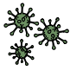

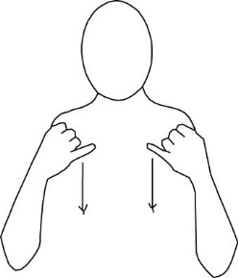 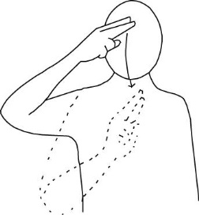 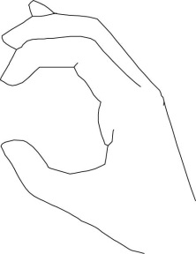

You might **hear** people talking about it. Or hear about it on the News (**TV**).

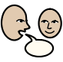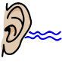 

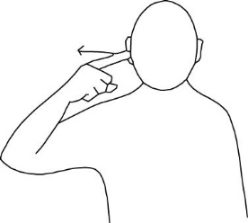 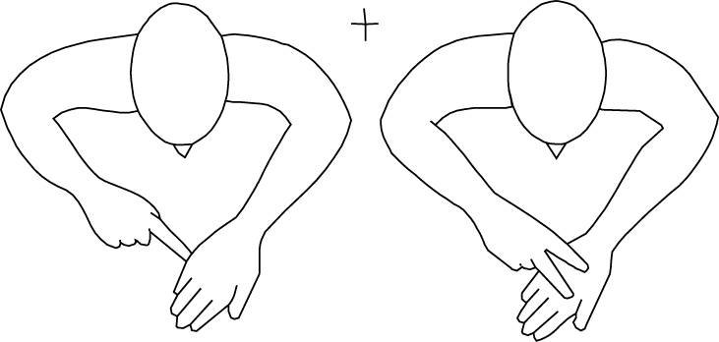

Sometimes Corona Virus gets called ‘COVID 19’ as well. It is the **same** thing.

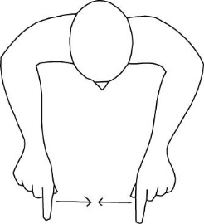

A virus is something which can **make** people **poorly** if it gets in their body. A virus is a bit like a cold or the flu.

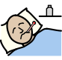

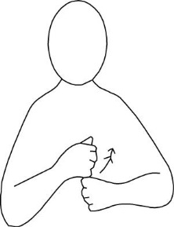 

People with Corona virus can

Have a headache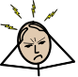 *(use flat hand, facing body, shake this in front of head to indicate pain in head)*

feel **cold**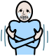 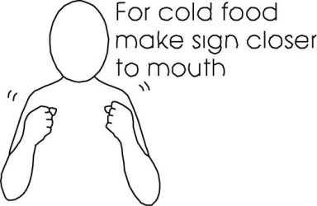

feel **hot**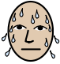 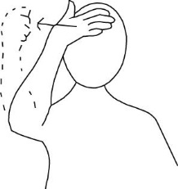

have a **sore throat** 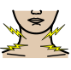 *(use the pain sign again over the throat)*

and have a **cough**. 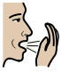 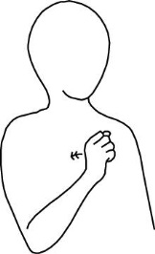

**Everybody** has to **stay at home** to **help stop** the **virus** spreading.

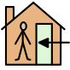  

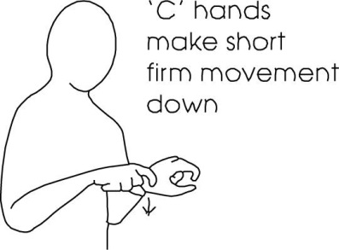 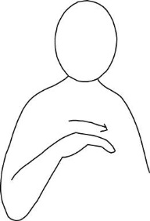 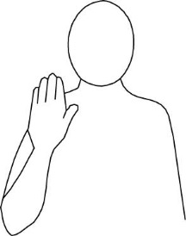

We **do not go** out to see people right now.

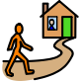

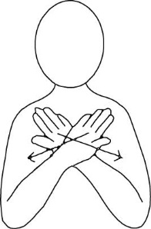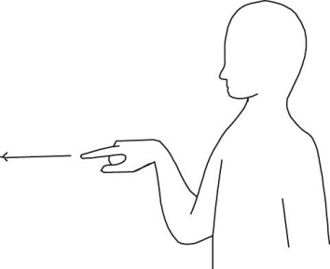

We **do not hold hands** with people right now.



 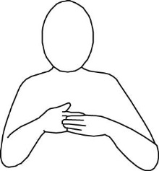

I do jobs and **fun** things at **home**.

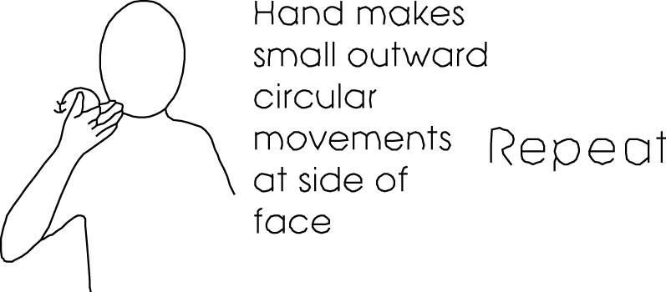

I can go out in the **garden**

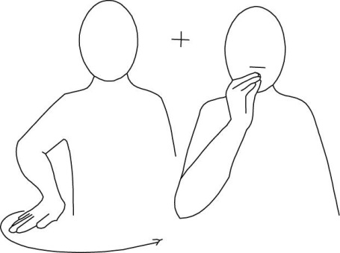

or for a **walk** to get some fresh air.

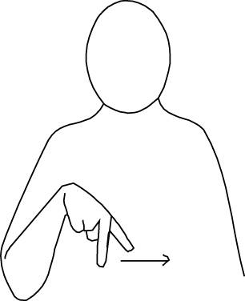

Keeping clean keeps the virus away. So I **wash my hands** with soap and water.

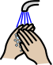

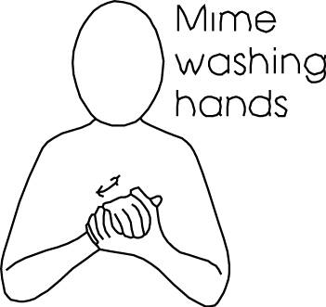

If I **cough or sneeze** I use a **tissue**. I put it in the bin and then I **wash my hands**.

  

 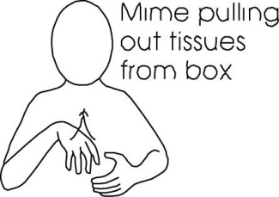

It can be frustrating when things are different. It can be **difficult** not going out.

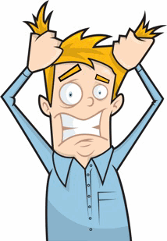 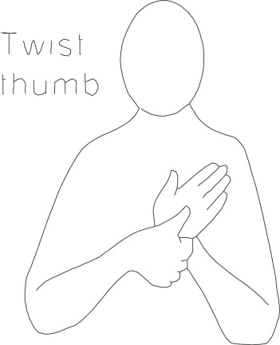

I am doing a really **good job** by staying at home.

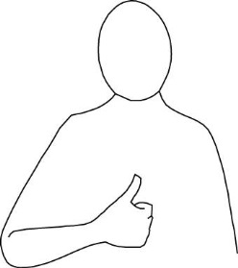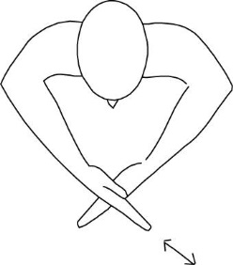

I am **helping** to **stop** the **virus**

 

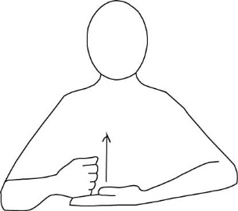 

When Corona **Virus** is gone (**finished**) everything will go back to normal/ be **okay**.

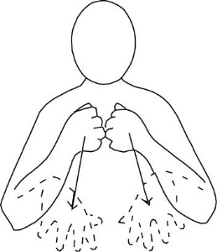 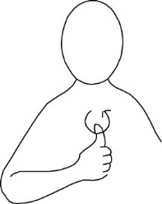

I have been **learning** about the **Corona Virus**.

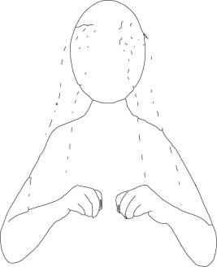  

**The end.**